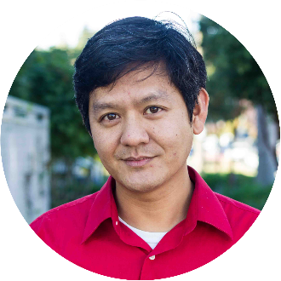
Writer and Nonprofit Diversity Advocate, Vu Le on ???
  - Day 4 Keynote Address | Wednesday, August 26, 2020

Strength in Diversity
Session description.

Vu Le, Nonprofit AF
Vu Le (“voo lay”) is a writer, speaker, vegan, Pisces, and the former Executive Director of RVC, a nonprofit in Seattle that promotes social justice by developing leaders of color, strengthening organizations led by communities of color, and fostering collaboration between diverse communities.
Vu’s passion to make the world better, combined with a low score on the Law School Admission Test, drove him into the field of nonprofit work, where he learned that we should take the work seriously, but not ourselves. There’s tons of humor in the nonprofit world, and someone needs to document it. He is going to do that, with the hope that one day, a TV producer will see how cool and interesting our field is and make a show about nonprofit work, featuring attractive actors attending strategic planning meetings and filing 990 tax forms.

Known for his no-BS approach, irreverent sense of humor, and love of unicorns, Vu has been featured in dozens, if not hundreds, of his own blog posts at NonprofitAF.com, formerly nonprofitwithballs.com.

